**Course 2 - Backend and Database Development**

1. Create dynamic web project in new workspace and add tomcat server 9.x version and add web.xml file.
2. Then convert this project into maven project.
3. Maven tool provide use pom.xml file. Inside this file please add dependencies tag which contains two dependency ie mysql connector and jstl dependency. Update the project.
4. Open mysql database using console and workbench.
5. Create the database ie zumba_db.
6. Move inside a database.
7. Batches and participants two tables.
8. Batch table -🡪 bid of type int with primary key, typeofbatch(morning/evening), time (7am to 8am, 8am to 9am, 8pm to 9pm etc).
9. Participants table 🡪 pid of type int with primary key, fname,lname, age, phonenumber(unique),bid (FK)

Batch

PK

Bid TypeOfBatch Time

100, Morning , 8am-9am

101,Morning, 9am-10am

102,Evening,7pm-8pm

Participants

PK FK

Pid FName, LName, age, phonenumber, Bid

1, Steven, Patel, 21,985857575,100

2,Lex,More, 24,88686868,100

**Zumba_App.sql**

This file contains all sql syntax

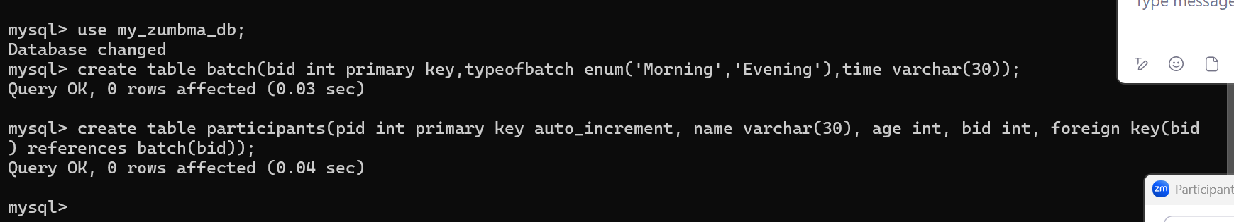

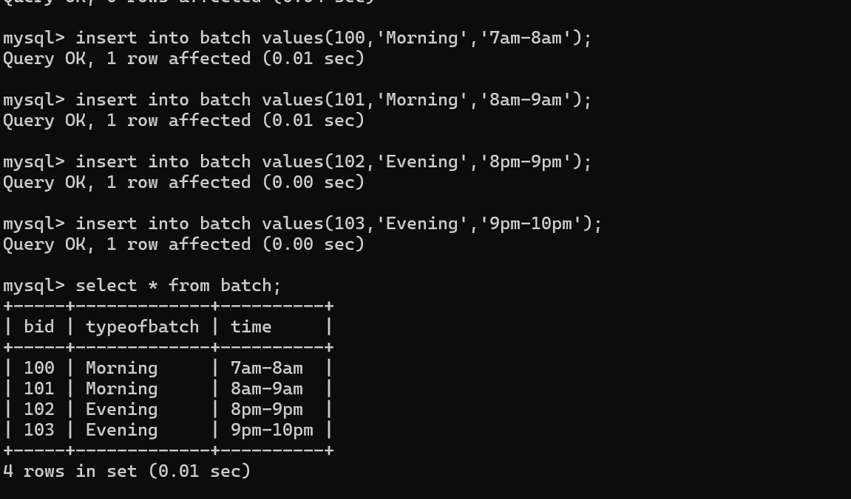

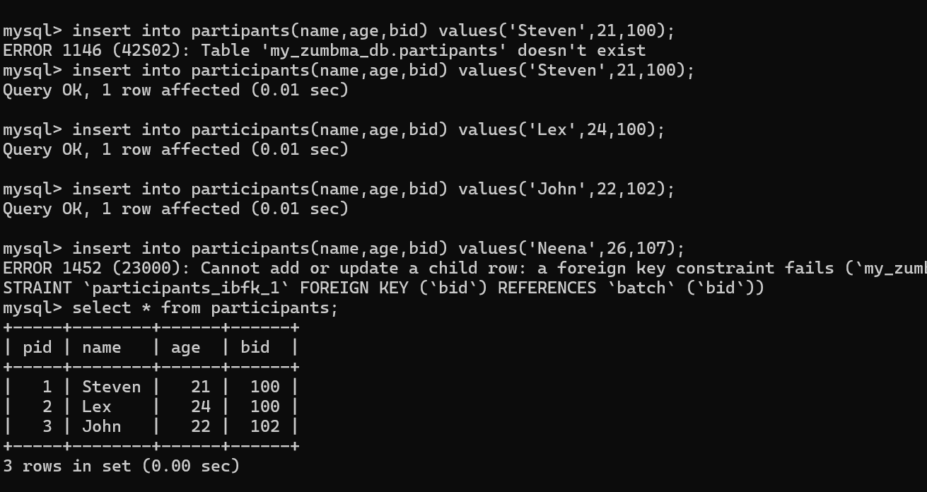

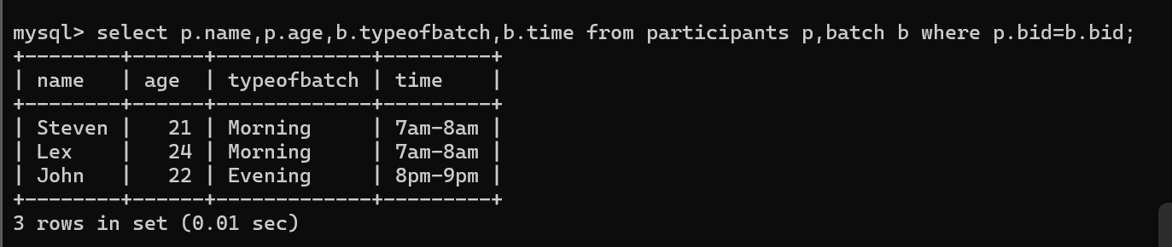

Batch

PK

100, Morning , 8am-9am

101,Morning, 9am-10am

102,Evening,7pm-8pm

Participants

PK

1000, Steven, Patel, 21,985857575

1001,Lex,More, 24,88686868

BatchParticipants

BPId(PK auto_increment), BatchID(FK), PatcipantsId(FK)

1,100,1000

2,102,1000

Select b.typeofbatch,b.time,p.name,p.age,bp.bpid from batch b, partipants p, batchparticipants bp where b.bid=bpid.batchid and p.pid=bp.particpantsid;

1. Number of table ie Batch and Participants you need to create JavaBean class in dynamic web project.

com.zumba.bean -🡪

Batch -🡪 normal class

int pid, String typeofbatch, String time

setter/getter method, empty and parameter constructor

Participants🡪 normal class

Int pid, String fname,String lname,int age, String phonenumber, int bid

setter/getter method, empty and parameter constructor

1. Resource class which provide database connection.

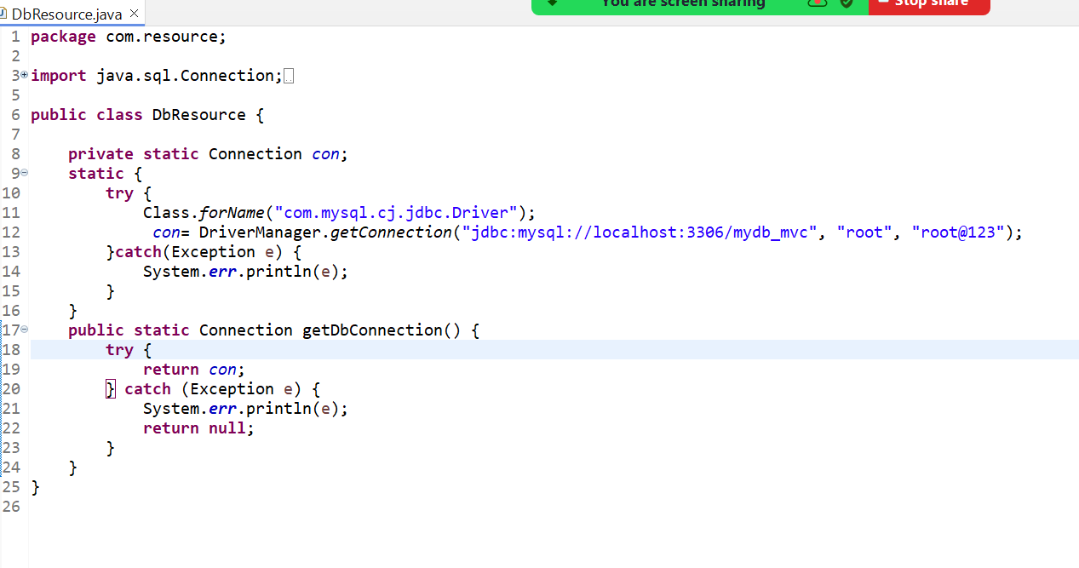

1. Now we need to write dao class which contains database logic.

com.zumba.dao

PariticipantsDao -🡪 normal class

addParticipants executeUpdate return type if int

viewParticipants

BatchDao -🡪 Normal class

addBatch executeUpdate return type if int

viewBatches

1. Now we need to write service class which contains business logic. (optional)

com.zumba.service

ParticipantsService

BatchService

14.Servlet

com.zumba.controller -🡪 Servlet program

ParticipantsController 🡪

doGet for retrieve purpose

doPost for store purpose

BatchController -🡪

doGet for retrieve purpose

doPost for store purpose

15. View

Index.html -🡪 index.jsp as first page

AddPariticpants.jsp, ViewParticipants.jsp addBatch.jsp, viewBatch.jsp etc

AddParticipants.jsp

AddBatch.jsp

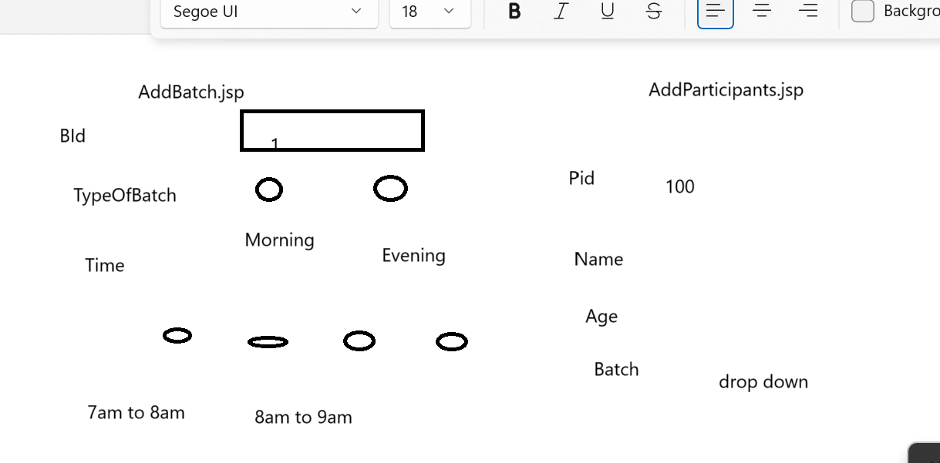

ViewParticipants.jsp

Display all participants details in table or any other format.

ViewBatch.jsp

Display all batch details in table or any other format.